**Lab 7 Managing Windows Server 2016**

**Network Services**

**Lab Assessment 2 Requirements:**

You are given time **until Friday 11:30pm** to complete Lab 06 on **a provided platform independently** without assistance from other people including your Lab Tutor and classmates:

1. Rename this word document as **Lab_Assessment_2_YourName_YourID.docx** where YourName is your real name and YourID is your VU Student ID with s.
2. In this lab assessment, you are required to **capture 13 screens (with figure captions) and answer 7 questions**. **All screen shots must show date and time from task bar**. Each is worth 5 points and make up a total of 100 points.
3. Capture the required screenshots and insert them underneath their step instructions. Then save to your file. Marks will be subject to quality of screenshots and figure captions.
4. Upon completion, upload the following **two files** via dropbox on VU Collaborate:
   1. **CoES Assignment Cover Sheet** and
   2. **Lab_Assessment_2_YourName_YourID.docx**

**Late Submission Penalty**

* 1-2 days – 10 points each day
* 3-6 days – 20 points each day
* After 6 days – **0** (**zero**) mark

**Deduction**

* Missing Cover Sheet – 5 points
* Wrong file name – 5 points
* Combined cover sheet file with Lab Assessment file – 5 points
* Missing figure numbers (step numbers) – 5 points
* Missing figure captions – 5 points
* Captured screens without task bar – up to 50 points

**Task 2 – Activity**

**Activity 7-1 Installing and Configuring DHCP**

**Objective**: Learn how to install and configure the DHCP role.

**Description**: DHCP is installed as a server role in Windows Server 2016 using Server Manager. In this activity, you install DHCP. Also, you practice configuring a scope on a DHCP server. Before you start, obtain the address or computer name of a DNS server from Activity 3-1 (or use the address of this computer). You will also need to know the subnet mask and authorization of DHCP server. In later steps, you verify that the DHCP server you have configured is set up to automatically register with a DNS server the IP addresses that it leases and that it is configured for the types of clients on your network.

**Requirements**: Take Screenshots on Steps **1.0,** **1.10, 1.14, 1.17, 1.18, and 1.35**, and answer questions on Steps **1.19, 1.21, 1.25 and 1.28**.

**1.0** Open Command/PowerShell prompt, type: **date; ipconfig /all** (two commands in one line) as below. Press **Enter**.

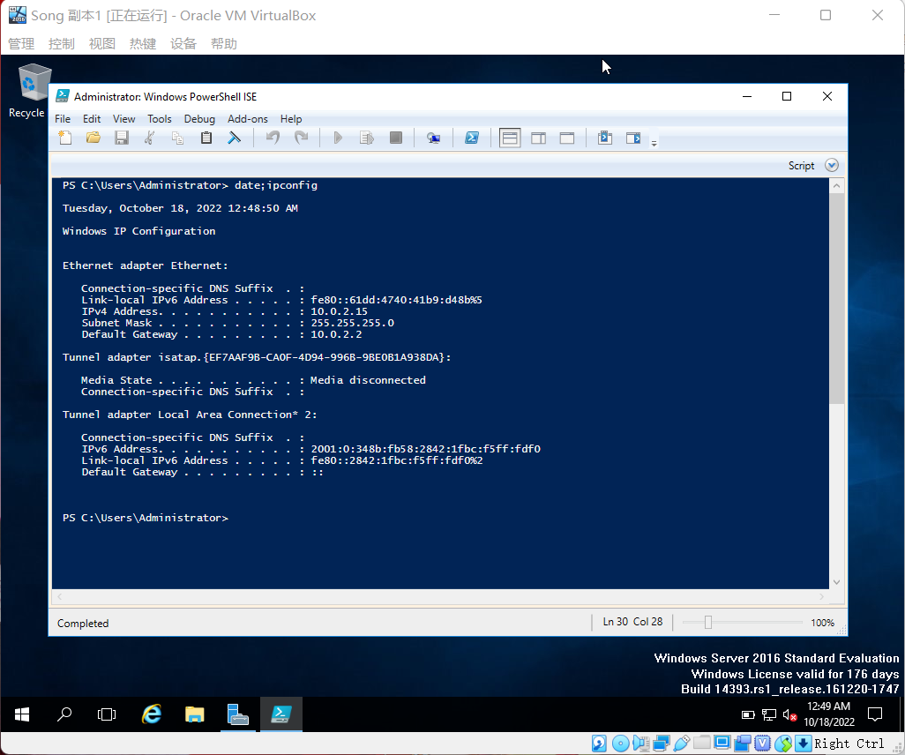

Figure 1.0 Windows Server 2016 Info 1

1.1 Open Server Manager, if necessary.

1.2 Click Manage and click Add Roles and Features.

1.3 If you see the Before you begin window, click Next.

1.4 Make sure that Role-based or feature-based installation is selected in the Select installation type window. Click Next.

1.5 In the Select destination server window, ensure your server is selected and click Next.

1.6 Click the box for DHCP Server in the Select server roles window.

1.7 Click Add Features in the Add Roles and Features Wizard box (to install the DHCP management tool).

1.8 Click Next in the Select server roles window.

1.9 Click Next in the Select features window.

**1.10** In the DHCP Server window, read the information. Click Next.

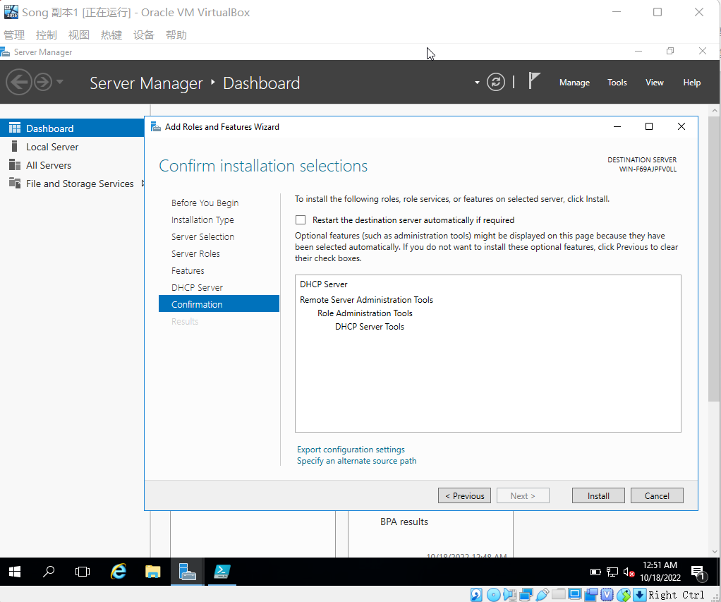

Figure 1.1 Windows Server 2016 Info 2

1.11 Click Install in the Confirm installation selections window.

1.12 Click Close.

1.13 Click Tools and click DHCP.

**1.14** In the tree in the left pane of the DHCP window, double-click the name of the server under DHCP, such as accounting (or click the right-pointing arrow in front of the server name), to view IPv4 and IPv6 listed under the server name.

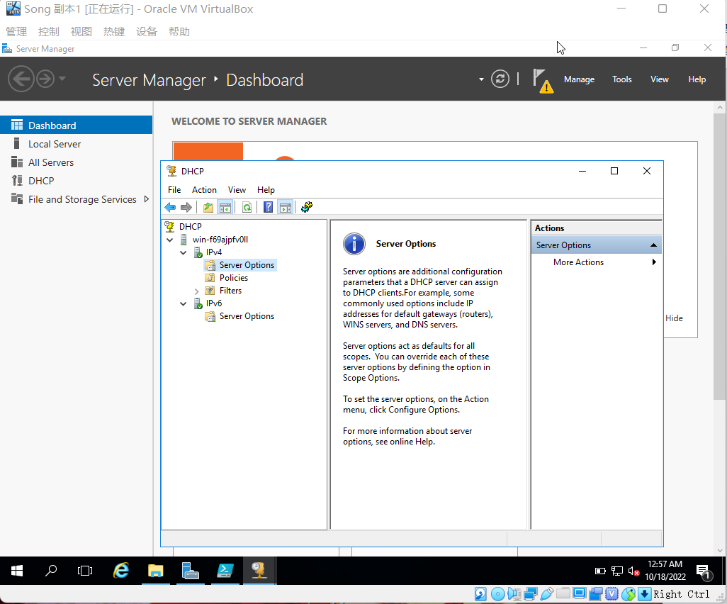

Figure 1.2 Windows Server 2016 Info 3

1.15 In the left pane, click IPv4 to view the configuration information in the middle pane. Right-click IPv4 and click New Scope.

1.16 Click Next after the New Scope Wizard starts.

**1.17** Enter **YourFirstName** for the scope so it is easy for you to identify as you maintain it, i.e. **Admin** plus Your First Name (**AdminYourFirstName**), and enter a description for the scope, such as Admin area subnet. Click Next.

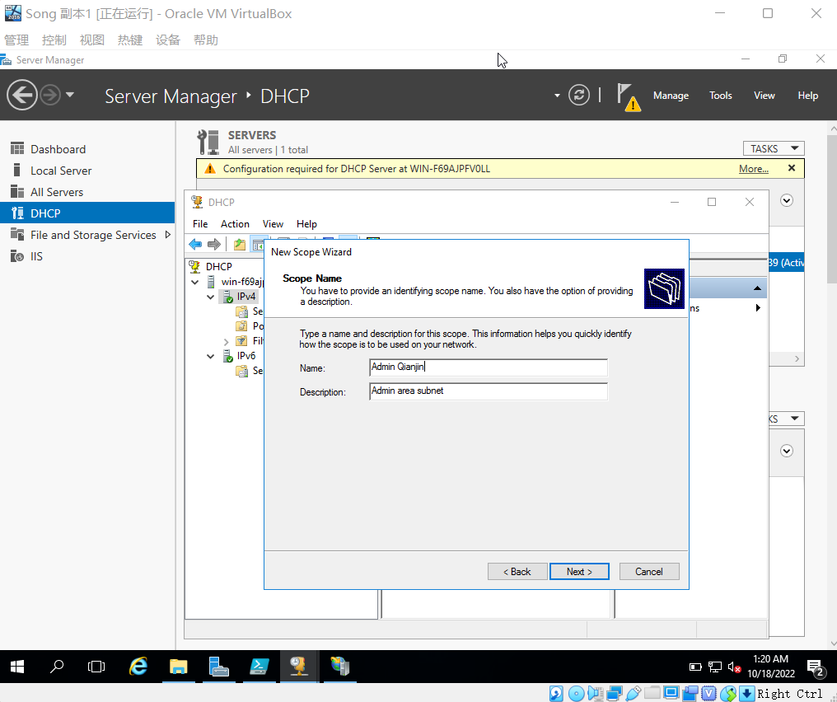

Figure 1.3 Windows Server 2016 Info 4

**1.18** Enter the start and end IP addresses, such as 198.4.100.51 and 198.4.100.99. To go from field to field, press the period key (when you enter fewer than three numbers) If necessary, enter the subnet mask, such as 255.255.255.0. Click Next.

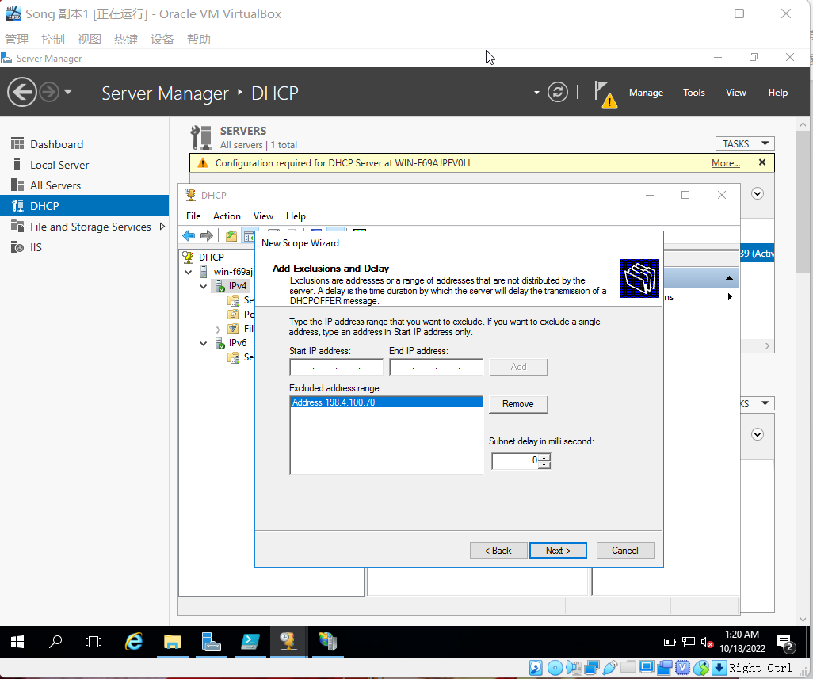

Figure 1.4 Windows Server 2016 Info 5

**1.19** In the Add Exclusions and Delay window, enter an address to exclude, such as 198.4.100.70, in the Start IP address box and click Add.

• What happens after you click Add? Do you need to enter an ending address?

The lease term window pops up.

NO

1.20 Click Next.

**1.21** You can now configure the lease duration.

• What is the default lease time? For what types of situations would this default be appropriate?

**8 days， For mobile networks that consist mainly of**

**portable computers or dial-up clients, shorter lease durations can be useful.**

**for a stable network that consists mainly of desktop computers at fixed**

**locations, longer lease durations are more appropriate.**

1.22 Change the default lease time to 14 days. Click Next.

1.23 Ensure that “Yes, I want to configure these options now” is selected and click Next.

1.24 The next dialog box offers the ability to enter an IP address for a router (default gateway). You would configure this information if access to the addresses in this scope is through a router (default gateway). Click Next.

**1.25** Enter the parent domain in which DNS name resolution will occur, such as s1234567.com (your domain will be entered by default, but you can change it). Select IP address shown in the bottom right box. Click Next.

• How would you enter more than one DNS server?

**After clicking the add button, enter the IP address.**

1.26 In the next dialog box, you can enter the names and IP addresses of WINS servers. This would be used on networks that have old Windows Server computers in which NetBIOS naming is used and so that these names can be mapped to IP addresses. (Entering the name of your WINS server is optional. If you do, click Resolve and then click Add.) Click Next. (If you see the WINS Servers dialog box, click Next.)

1.27 Ensure that “Yes, I want to activate this scope now” is selected and then click Next (or click Cancel if you do not have permission to finish creating the scope).

**1.28** Click Finish.

• What now appears in the middle pane of the DHCP window? (You may need to select Address Pool in the left pane under Scope to view this.)

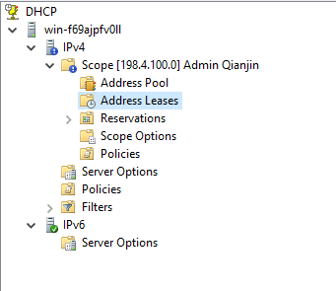

1.29 Your server may be authorized by default, but you will likely have to authorize it. You can verify this by right-clicking the server name in the tree. If you see the menu option Unauthorize, this means your server is already authorized and you should click an open space to close the menu. If instead you see Authorize in the menu, click this option to authorize the server.

1.30 Ensure the server in the left pane of DHCP tool is expanded to show the elements under it.

1.31 Double-click IPv4 to select it.

1.32 Right-click IPv4 and then click Properties.

1.33 Click the DNS tab and make sure that the box for Enable DNS dynamic updates according to the settings below is checked. Clients running the Windows 7, 8/8.1, 10, Server 2012/R2, and Server 2016 operating systems can request to update a DNS server.

1.34 Ensure Dynamically update DNS records only if requested by the DHCP clients is selected. If older operating systems are connecting to the network, such as Windows 98 or Windows 95, which do not request to update a DNS server, click instead Always dynamically update DNS records—which means that the DHCP server takes the responsibility to update the DNS server’s records every time a client obtains the IP address.

**1.35** Make sure that Discard A and PTR records when lease is deleted is checked, so that the DHCP server alerts the DNS server to delete a record each time a lease is up. If some older clients are running Windows 95, 98, and NT (unlikely but possible), also check Dynamically update DNS records for DHCP clients that do not request updates (for example, clients running Windows NT 4.0).

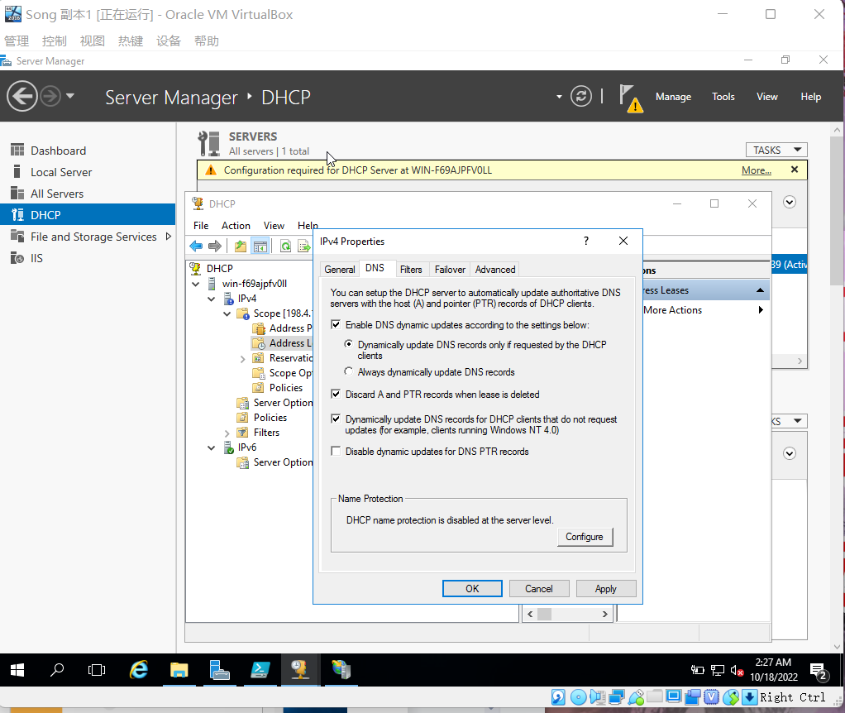

Figure 1.5 Windows Server 2016 Info 6

1.36 Click OK.

1.37 Close the DHCP window.

**Activity 7-2 Installing and Configuring IIS**

**Objective**: Learn how to install and configure IIS.

**Description**: The Web Server (IIS) role is used to turn your Windows Server 2016 server into a website hosting server. In this activity, you use Server Manager to install the Web Server (IIS) role.

Requirements: Take screenshots on **Steps 2.0, 2.6, 2.12, 2.18, 2.27, 2.33, 2.38**, and answer questions on **Steps 2.11, 2.21, and 2.25**.

**2.0** Open Command/PowerShell prompt, type: **date; ipconfig /all** (two commands in one line) as below. Press **Enter**.

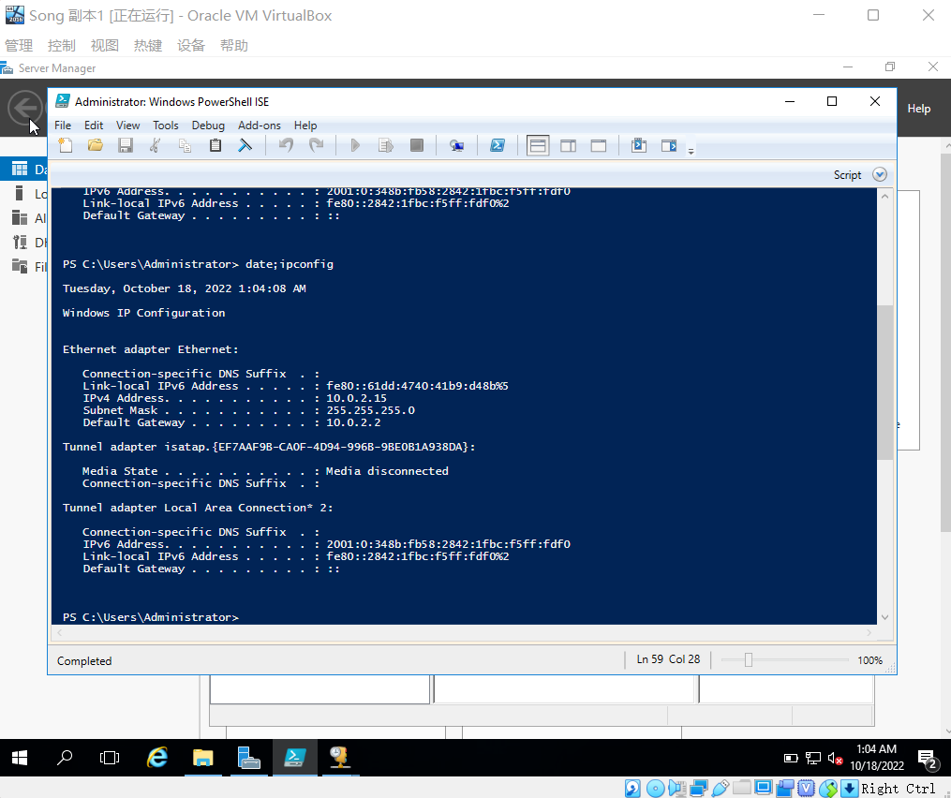

Figure 2.0 Windows Server 2016 Info 2

2.1 Open Server Manager, if it is not open.

2.2 Click Manage and click Add Roles and Features.

2.3 If you see the Before you begin window, click Next.

2.4 Make certain Role-based and feature-based installation is selected in the Select installation type window and click Next.

2.5 Your server should be selected in the Select destination server window. Click Next.

**2.6** Click the box for Web Server (IIS) in the Select server roles window.

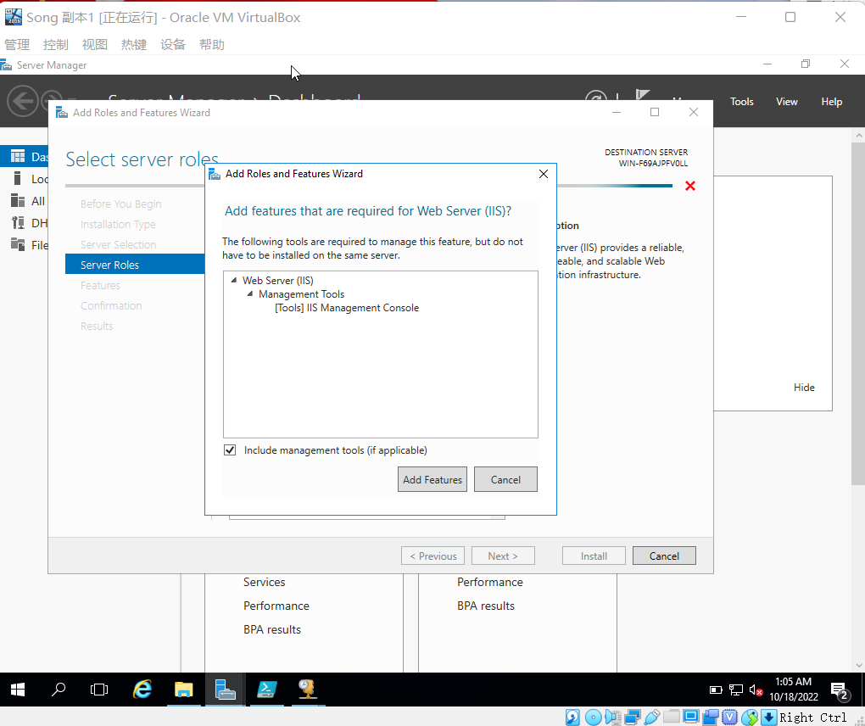

Figure 2.1 Windows Server 2016 Info 3

2.7 So that you install the module for IIS Management Console, click Add Features in the Add Roles and Features Wizard.

2.8 Click Next in the Select server roles window.

2.9 Click Next in the Select features window.

2.10 Review the information window about Web Server Role (IIS) and then click Next.

**2.11** Review the modules that are installed by default in the Select role services window.   
• Record the modules checked by default.

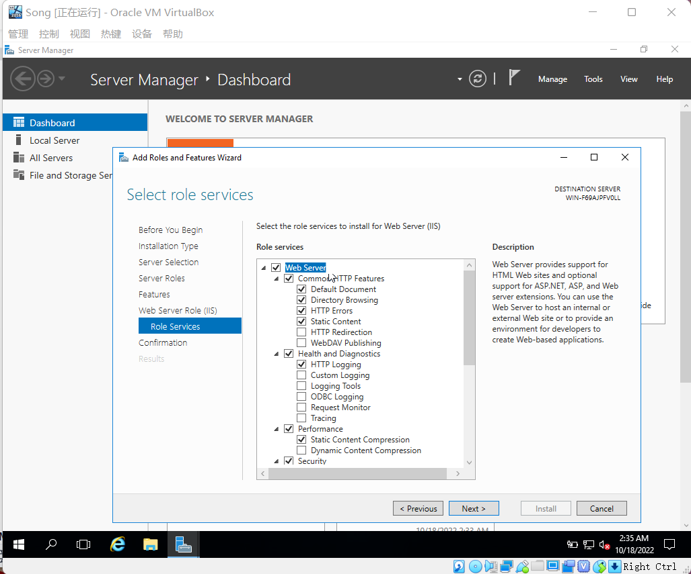

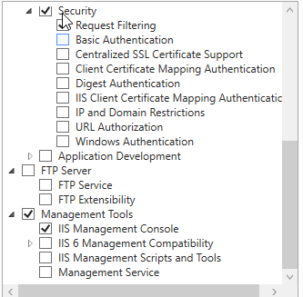

**2.12** Under Security, click the box for IIS Client Certificate Mapping Authentication and read its description on the right side of the window. This selection enables you to use digital IDs for security.

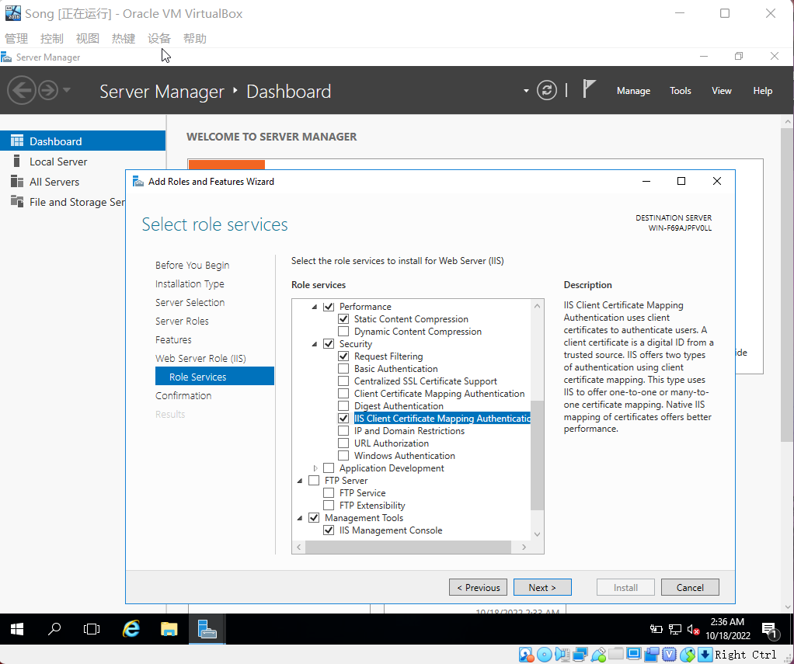

Figure 2.2 Windows Server 2016 Info 4

2.13 Click Next in the Select role services window.

2.14 Review your selections and click Install.

2.15 Click Close.

2.16 Click Tools and click Internet Information Services (IIS) Manager.

2.17 Expand the tree in the left pane to view Default Web Site under the Sites folder. Right-click Default Web Site in the tree and click Add Virtual Directory.

**2.18** Enter an alias for the virtual directory, which users will employ to access it, i.e. www plus your last name at the end, such as **wwwYourLastName**. Also, enter the path to the physical folder i.e. C:\Users\Student\**wwwYourLastName** which you can choose to “Make New Folder” by browsing **…** folder option. Click OK.

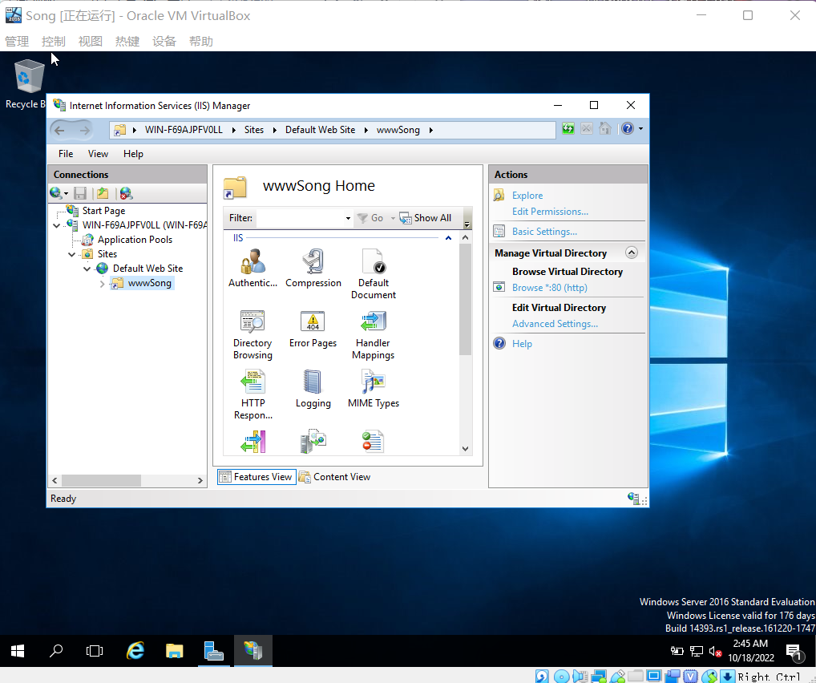

Figure 2.3 Windows Server 2016 Info 5

2.19 In the tree under Default Web Site (if necessary, click the right pointing arrow to expand it), right-click the virtual directory you created and click Edit Permissions.

2.20 Click the Security tab to view the current permissions.

**2.21** Click the Sharing tab.

• How can you set up this folder for sharing?

**Click the Share button**

2.22 Click Cancel in the Properties dialog box.

2.23 Open IIS Manager, if you have closed it.

2.24 If necessary, expand the tree under the Sites folder to see Default Web Site.

**2.25** Right-click Default Web Site to see the menu and review its contents Point to Manage Website.

• How can you rename the website? Also, how can you restart the website if it is stopped?

**Right-click the website, click rename.**

**Right-click the website, click Manage Website, and click restart.**

2.26 Click the pointer in a blank area to close the open menu.

**2.27** Double-click Default Document in the middle pane. Notice that Default.htm is set up to display first when the client connects to the website without specifying a file to access. Right-click iisstart.htm and notice there is an option to move it up the list.

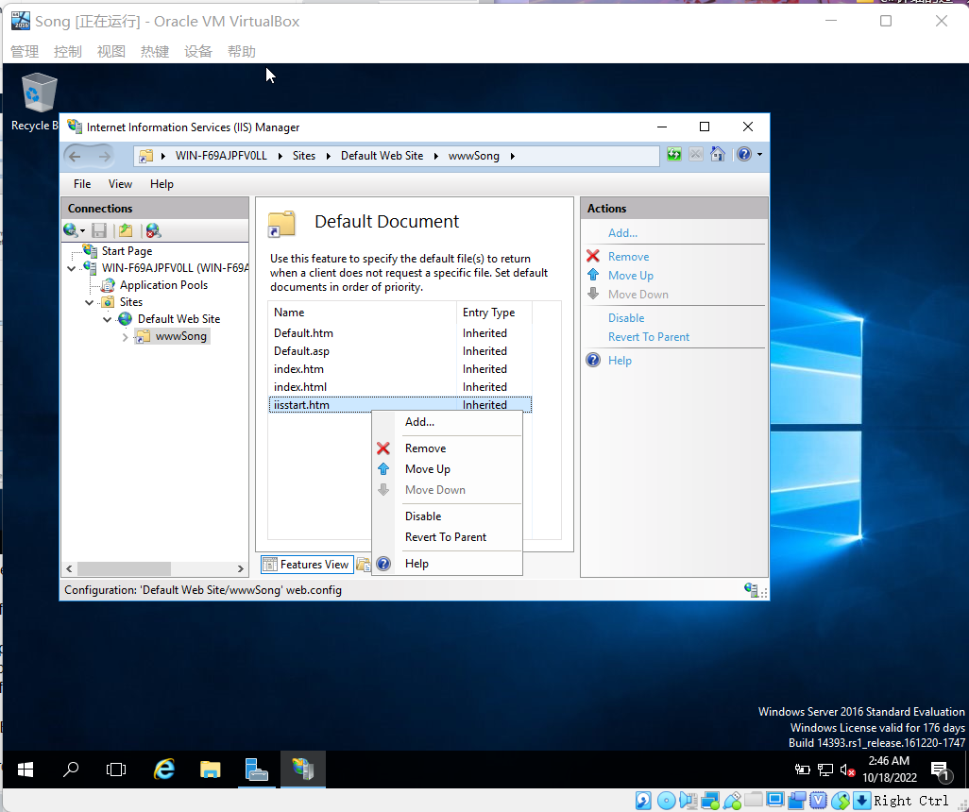

Figure 2.4 Windows Server 2016 Info 6

2.28 Click the back arrow in the upper-left side of the Internet Information Services (IIS) Manager window.

2.29 Double-click Directory Browsing in the middle pane.

2.30 In the right pane, click Enable to enable directory browsing.

2.31 Click the back arrow in the upper-left side of the Internet Information Services (IIS) Manager window.

2.32 Right-click Default Web Site in the tree, click Edit Permissions, and click the Security tab.

**2.33** Click Users (s1234567\IIS_IUSERS) under Group or user names: to view the security given to web users in the domain.

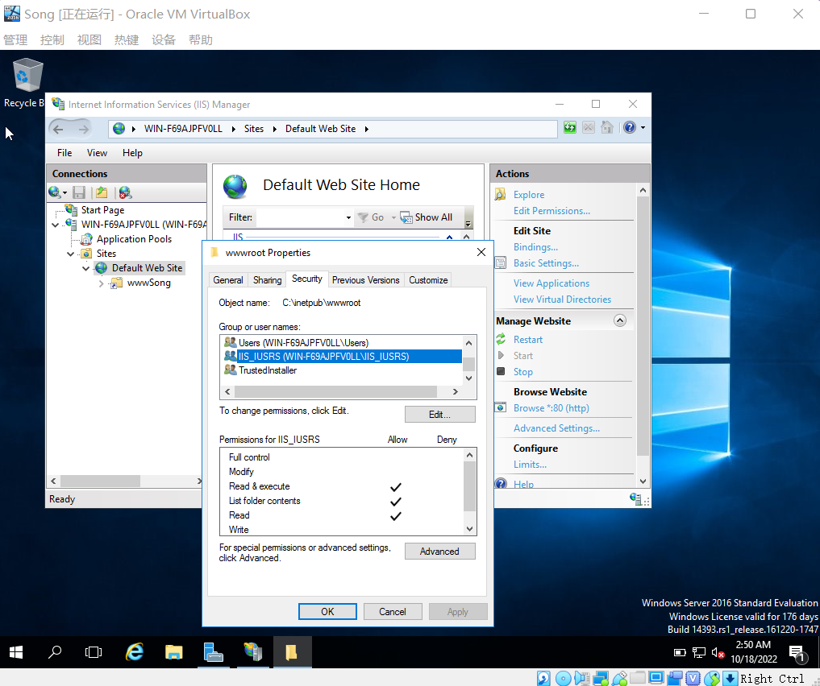

Figure 2.5 Windows Server 2016 Info 7

2.34 Click Cancel in the Properties dialog box.

2.35 In the left pane, click Default Web Site in the tree, so that it is highlighted.

2.36 In the right pane, find the Configure section and click Limits.

2.37 Enter 240 in the Connection time-out (in seconds): box to increase the amount of time a user can be connected without taking action.

**2.38** Click the box for Limit number of connections. Enter 500 as the number for simultaneous connections so you can control the load on the server. This is a number you should monitor in the future. If the server is frequently overloaded with users and performing slowly, you can reduce this number, for example, by 50 at a time, as needed. Click OK.

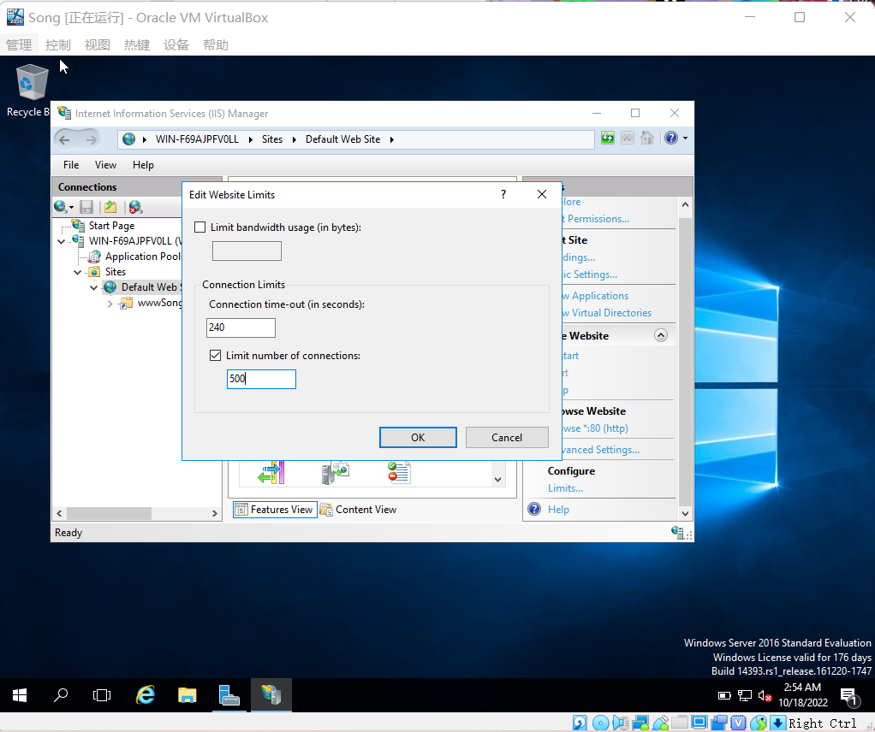

Figure 2.6 Windows Server 2016 Info 8

2.39 Close the Internet Information Services (IIS) Manager window.

**Congratulations! You reach the end of Lab Assessment 2**.

Logon VU Collaborate and upload two separated files:

1. **CoES Assignment Cover Sheet**
2. **Lab_Assessment_2_YourName_YourID.docx**

via dropbox.

**Turn off your virtual machine on a provided platform.**